Philosophy 320L – Philosophy in Translation: Latin

Saint Augustine’s Confessions

Spring 2019

Syllabus

Jeffrey K. McDonough

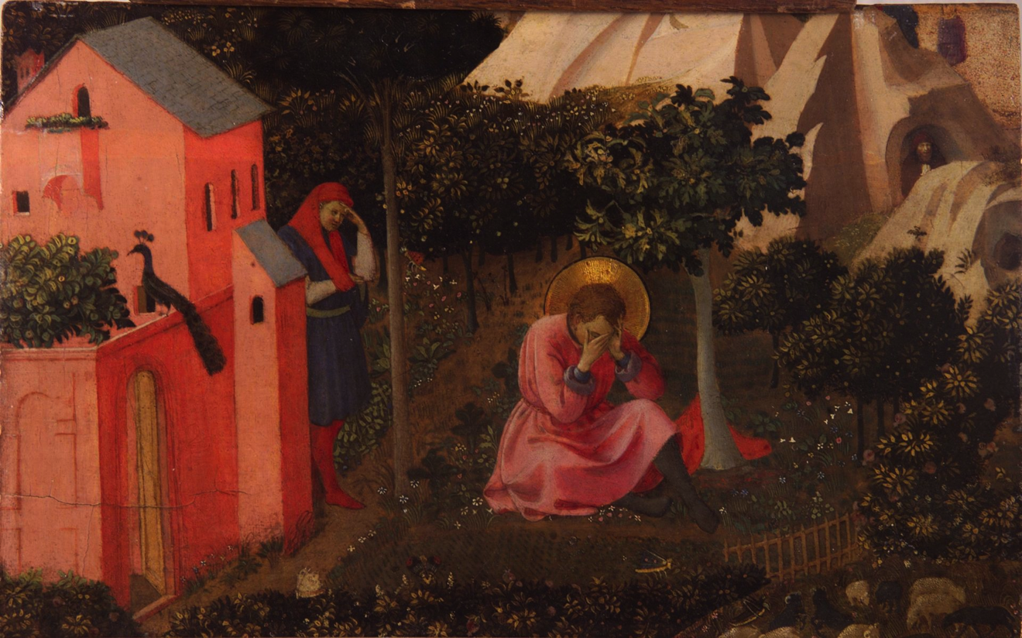

Important Information:
Meeting: Emerson Hall 107 (Bechtel Room), Thursdays 3:00 – 4:30
Professor: Jeffrey McDonough
Office Hours: 202 Emerson Hall, TBD
Email: jkmcdon@fas.harvard.edu

Course Description:

Saint Augustine of Hippo exerted an enormous influence over the history of western thought, and the Confessions is his undisputed masterpiece, rich in philosophy, theology, and rhetoric. This course will meet weekly to read passages in Latin from Augustine’s Confessions. It is open to undergraduates, graduates, and faculty of all reading levels. It can be audited with minimal commitment or taken as a course towards the satisfaction of the Philosophy Department’s language requirement. Please contact the instructor if you would like to be placed on the course e-mail distribution list.

Texts and Optional Background Reading:

Augustine: Confessions, ed. J.J. O’Donnell with commentary. Posted on-line at: http://www.stoa.org/hippo/frame_entry.html (A Latin only edition of Augustine’s Confessions with extensive commentary that we will be using for class.)

Augustine Confessions, Books 1-8, ed. and trans. Carolyn J.-B. Hammond, Harvard University Press 2014. (The Loeb Library edition of the first eight books of Augustine’s Confessions offering Latin text with facing English translation and notes.)

Augustine Confessions, Books 9-13, ed. and trans. Carolyn J.-B. Hammond, Harvard University Press 2016. (The Loeb Library edition of the last five books of Augustine’s Confessions offering Latin text with facing English translation and notes.)

Augustine, Confessions, trans. Henry Chadwick, Oxford University Press 1991. (A nice, modern edition of Augustine’s Confessions in English.)

Augustine, Confessions, trans. R. S. Pine-Coffin, Penguin 1961. (A classic translation of Augustine’s Confessions in English.)

David Vincent Meconi and Eleonore Stump, eds. The Cambridge Companion to Augustine, Second Edition, Cambridge University Press 2014. (A nice collection of accessible articles on Augustine’s philosophical thought.)

John Rist, Augustine: Ancient Thought Baptized, Cambridge University Press 1994. (A learned overview of Augustine’s philosophical thought.)

Michael Mendelson, "Saint Augustine", The Stanford Encyclopedia of Philosophy (Winter 2016 Edition), Edward N. Zalta (ed.), URL = <https://plato.stanford.edu/archives/win2016/entries/augustine/> (A helpful overview of themes from Augustine. Includes a useful bibliography with a guide to selected Latin texts and critical editions.)

Peter Brown, Augustine of Hippo: A Biography University of California Press 2000. (A learned, helpful biography of Augustine.)

William Mann, Augustine's Confessions: Philosophy in Autobiography, Oxford University Press 2014. (A recent collection of papers centered on philosophical themes from Augustine’s Confessions.)

Tentative Schedule

Latin text links are to: Augustine: Confessions, ed. J.J. O’Donnell with commentary. Posted on-line at: http://www.stoa.org/hippo/frame_entry.html

Reading #1: Childhood, language, and schooling

Broader context: Book I

Latin reading: Paragraphs 1.6.8, 1.8.13, 1.9.15

Reading #2: Adolescences and Theft of the Pears

Broader context: Book II

Latin reading: Paragraphs 2.1.1, 2.4.9, 2.8.16

Reading #3: Theater, Cicero, and Manichaeism

Broader context: Book III

Latin reading: Paragraphs 3.2.2, 3.47, 3.7.12

Reading #4: Friendship

Broader context: Book IV
Latin reading: Paragraphs 4.4.8, 4.8.13, 4.9.14

Reading #5: Struggles with Materialism

Broader context: Book V

Latin reading: Paragraphs 5.10.20, 5.14.25

Reading #6: Worldly Preoccupations

Broader context: Book VI

Latin reading: Paragraphs 6.11.18, 6.11.20, 6.14.25

Reading #7: Evil and Good

Broader context: Book VII

Latin reading: Paragraphs 7.3.5, 7.11.17, 7.12.18

Reading #8: Conversion

Broader context: Book VIII

Latin reading: Paragraphs 8.12.28, 8.12.29, 8.12.30

Reading #9: Death of Monica

Broader context: Book IX

Latin reading: Paragraphs 9.8.18, 9.10.24, 9.12.33

Reading #10: Memory

Broader context: Book X

Latin reading: Paragraphs 10.8.12, 10.8.13, 10.8.14

Reading #11: Time

Broader context: Book XI

Latin reading: 11.10.12, 11.12.14, 11.13.15

Reading #12: Literal Meaning

Broader context: Book XII

Latin reading: 12.24.33, 12.25.35, 12.31.42

Reading #13: The Beginning and The End

Broader context: Book XIII

Latin reading: 13.28.43, 13.29.44, 13.38.53

The image is “Conversion of Saint Augustine,” by Fra Angelico (ca. 1395-1455).

